LAB EXPERIMENT RECORD
SET 21: Energy Consumption Data Analysis
Department | AI&DS
Course Code / Course Name | DSA0602 / Data Handling and Visualization
Experiment | Data Visualization using R
Name | Peram Mahitha
Register Number | 192524136
Date | 12 OCTOBER 2026
Day | Tuesday

SET 21: Energy Consumption Data Analysis
Aim:
To analyze energy consumption data by visualizing units consumed, temperature, renewable energy usage, and peak hours using R programs and an interactive Tableau dashboard.
Dataset: Energy Consumption
Sector | Region | Month | Temperature (°C) | Units Consumed | Renewable Usage (%) | Peak Hours
Residential | North | Jan | 15 | 320 | 22 | 4
Commercial | South | Jan | 24 | 540 | 38 | 6
Industrial | West | Feb | 20 | 880 | 12 | 8
Residential | East | Feb | 18 | 350 | 25 | 5
Commercial | North | Mar | 28 | 610 | 20 | 7
Industrial | South | Mar | 30 | 920 | 15 | 9
PROGRAM 1: Histogram and Density Plot (Units Consumed)
Aim: To visualize the distribution of units consumed and compare energy consumption values.
R Program:

graphics.off()

units <- c(320, 540, 880, 350, 610, 920)

hist(units,
probability = TRUE,
col = "lightblue",
main = "Distribution of Units Consumed",
xlab = "Units Consumed")

lines(density(units),
col = "red",
lwd = 2) 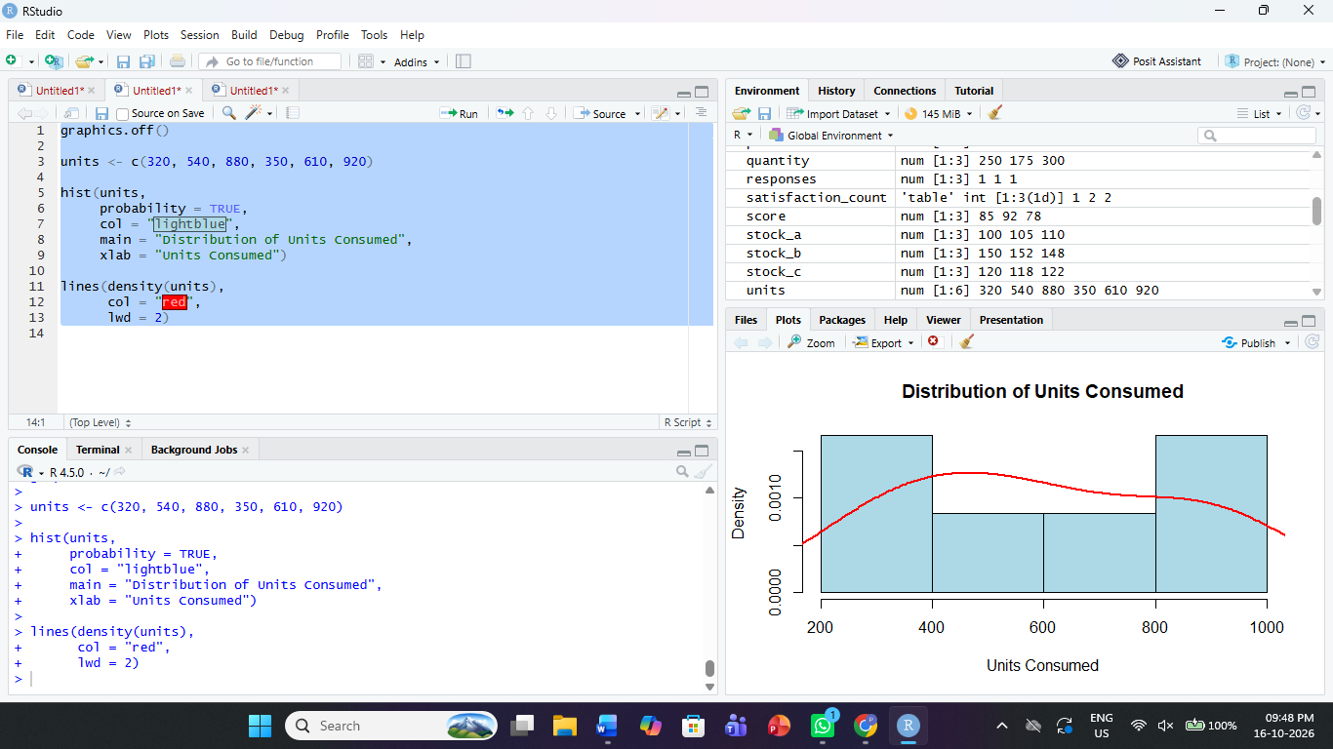
Observation: The histogram and density curve show the distribution of energy consumption. The values range from 320 to 920 units, with the highest consumption being 920 units.
PROGRAM 2: Scatter Plot (Temperature and Units Consumed)
Aim: To examine the relationship between temperature and energy consumption using a scatter plot.
R Program:

graphics.off()

temperature <- c(15, 24, 20, 18, 28, 30)
units <- c(320, 540, 880, 350, 610, 920)
peak_hours <- c(4, 6, 8, 5, 7, 9)

plot(temperature, units,
pch = 19,
col = "blue",
xlab = "Temperature (C)",
ylab = "Units Consumed",
main = "Temperature vs Energy Consumption")

text(temperature, units,
labels = peak_hours,
pos = 3)

legend("topleft",
legend = "Labels indicate peak hours",
bty = "n") 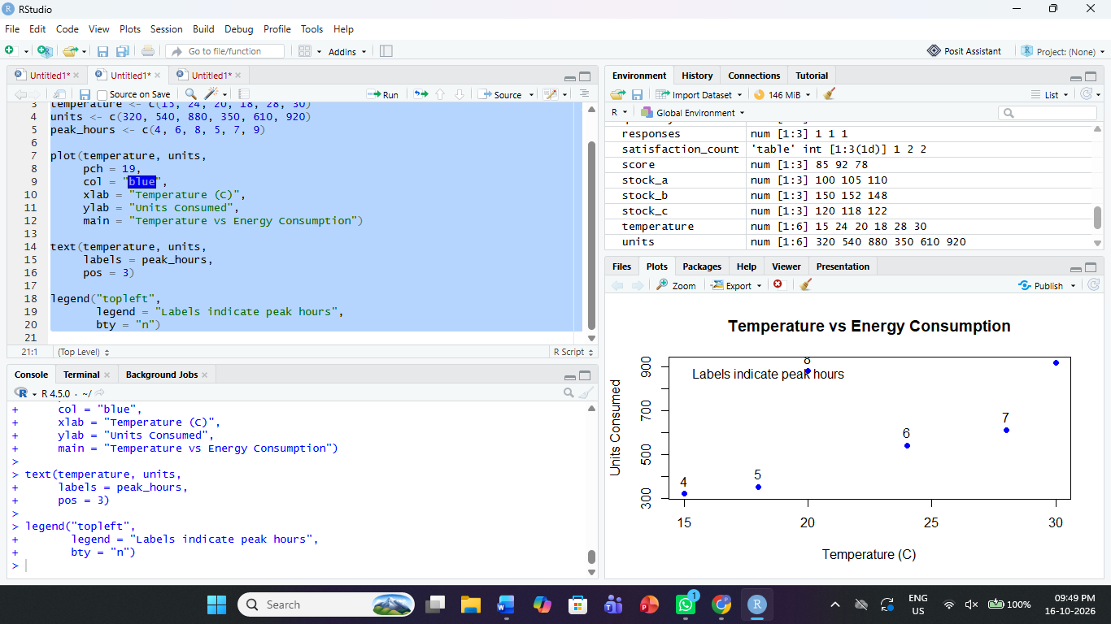
Observation: The scatter plot displays temperature against units consumed. Consumption generally increases at higher temperatures in some observations, although the six records do not establish a consistent relationship.
PROGRAM 3: Average Renewable Usage by Sector
Aim: To calculate and display average renewable energy usage for each sector.
R Program:

graphics.off()

sector <- c("Residential", "Commercial", "Industrial",
"Residential", "Commercial", "Industrial")

renewable <- c(22, 38, 12, 25, 20, 15)

avg_usage <- tapply(renewable, sector, mean)

barplot(avg_usage,
col = "lightgreen",
main = "Average Renewable Usage by Sector",
xlab = "Sector",
ylab = "Average Renewable Usage (%)")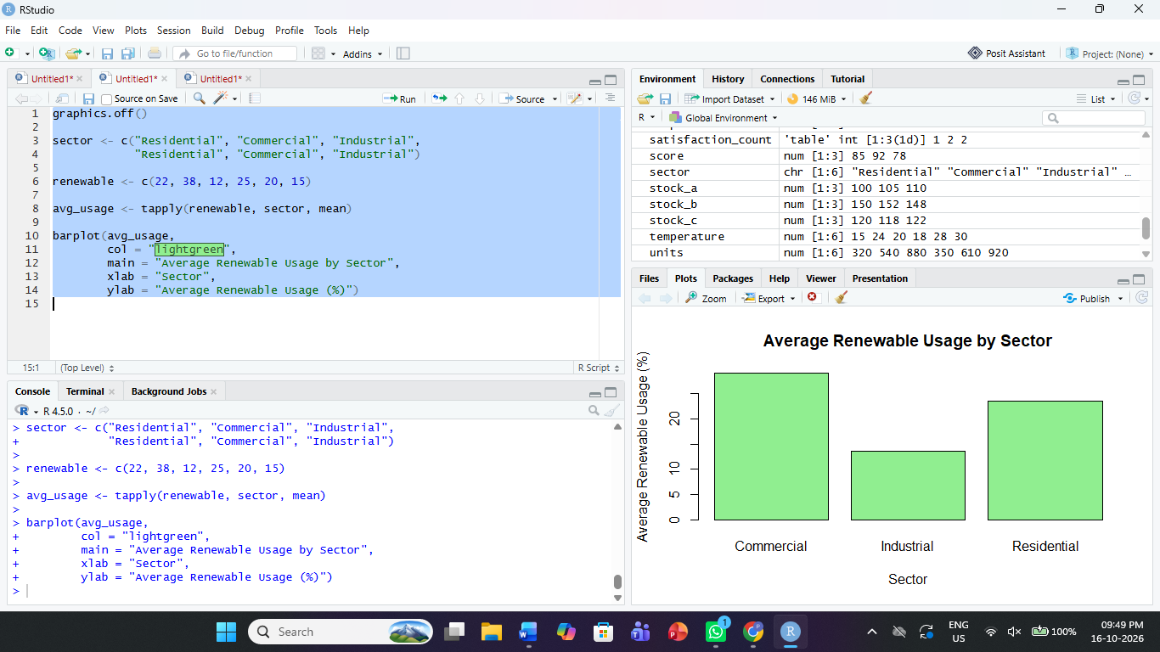
Observation: The average renewable usage is 23.5% for Residential, 29% for Commercial, and 13.5% for Industrial. Commercial has the highest average renewable usage among the three sectors.
PROGRAM 4: Energy Consumption Dashboard in Tableau
Aim: To create an interactive dashboard combining energy consumption distributions, temperature comparisons, renewable usage, and sector-wise records.
Steps in Tableau:
- Save the dataset as Energy_Consumption_Data.csv and connect it to Tableau.
- Sheet 1 – Consumption Distribution: Use Units Consumed to create a histogram.
- Sheet 2 – Temperature vs Consumption: Place Temperature on Columns and Units Consumed on Rows. Use a scatter plot and label marks with Peak Hours.
- Sheet 3 – Renewable Usage: Place Sector and Renewable Usage in the view. Use average aggregation to compare sectors.
- Sheet 4 – Heatmap: Place Sector and Region on the axes and Units Consumed on Color. Add Month as a filter.
- Create a dashboard and arrange the sheets. Enable Use as Filter for interactive exploration.
Observation: The dashboard combines consumption distributions, temperature comparisons, renewable usage, and sector-wise energy patterns. Filters help users explore records by month, sector, and region.
Procedure:
- Create vectors containing units consumed and temperature values.
- Use hist() and density() to analyze the distribution of consumption.
- Use plot() to examine the relationship between temperature and units consumed.
- Use tapply() to calculate average renewable usage by sector.
- Create a Tableau dashboard containing the charts and heatmap.
Result:
Energy consumption data was analyzed using a histogram, density curve, scatter plot, and sector-wise renewable usage chart in R. An interactive energy consumption dashboard was designed in Tableau.

